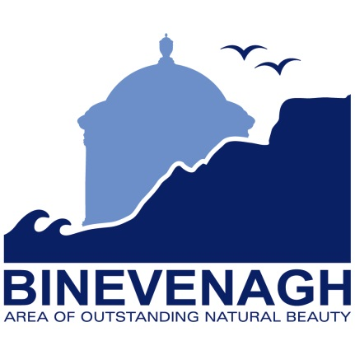
Areas of Outstanding Natural Beauty (AONBs) in Northern Ireland are designated under:
The Nature Conservation and Amenity Lands Order (Northern Ireland) 1985
This empowers the Department of the Environment to designate an Area of Outstanding Natural Beauty where:
“It considers the area is of such outstanding natural beauty that it is desirable that the provisions of this Article shall apply to it”
The provisions which the order refers to, state that where an area is designated as an Area of Outstanding Natural Beauty, the Department of the Environment may formulate proposals for:
- Conserving or enhancing the natural beauty or amenities of that area
- Conserving wildlife, historic objects or natural phenomena within it
- Promoting its enjoyment by the public
- Providing or maintaining public access to it
Within the Binevenagh AONB (designated in 2010), the Department of the Environment support a partnership approach to management of the AONB. This is achieved through financial support for the Binevenagh AONB Management Forum. The Causeway Coast and Glens Heritage Trust (CCGHT) provide a secretariat service for this group and manage a small AONB project budget which is currently supported by the Northern Ireland Environment Agency, Local Councils and the Northern Ireland Tourist Board. This currently provides around £8,000 per year for projects within the AONB. The Binevenagh AONB Management Forum therefore relays heavily on partner organisations to deliver projects and events which meet the aims of the Nature Conservation and Amenity Lands Order.
The first five year action plan for the Binevenagh AONB expired at the end of March 2015. The Binevenagh Management Forum are working hard to review progress-to-date, and identify targets for action between 2015 and 2020. To facilitate this work, CCGHT would like to gather a bank of project and funding ideas or actions which they would like to see delivered in the Binevenagh area between 2015 and 2020 These projects can be aspirational as well achievable within the outlined budget. To help with this process it would be fantastic if you could provide your comments on the following form and return to Tierna@ccght.org before Friday 18th December 2015

Objective One

Conserving or enhancing the natural beauty or amenities of the area

What projects, actions or funding ideas would you like to share for this objective?
Objective Two

Conserving wildlife, historic objects or natural phenomena

What projects, actions or funding ideas would you like to share for this objective?
Objective Three

Promoting enjoyment by the public

What projects, actions or funding ideas would you like to share for this objective?
Objective Four

Providing or maintaining public access

What projects, actions or funding ideas would you like to share for this objective?

