Challenge Fund: Tourism Experience Challenge Fund
Background
The Causeway Coast and Glens Heritage Trust was established in May 2002 as a partnership body with the responsibility of promoting and enhancing the unique qualities of the Causeway Coast and Glens area. This includes helping, developing and promoting sustainable tourism activities.
CCGHT is seeking to discover and encourage ongoing and potential tourism experiences through the Mid and East Antrim and Causeway Coast and Glens Borough Council areas, with a view to supporting private businesses to run regular, publicly visible tourism experiences increasing the stable offering to visitors and local economic benefits.
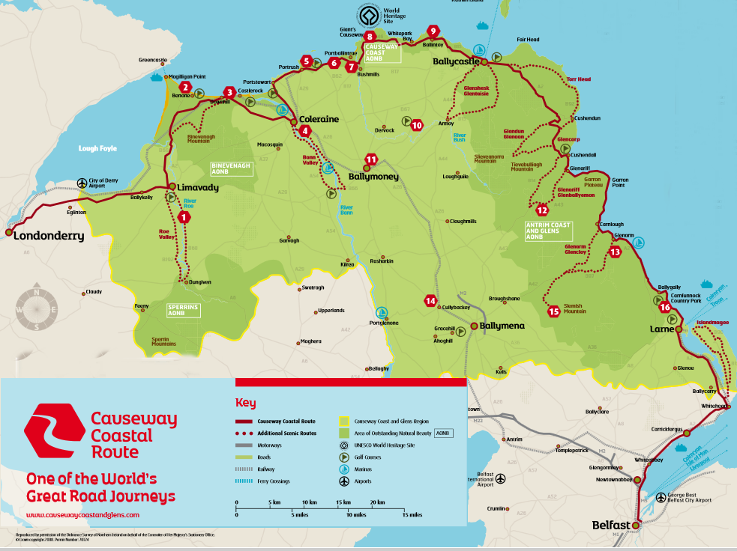
The green area on this map indicates the area considered as the Causeway Coast and Glens Area; Causeway Coast and Glens Borough Council and Mid and East Antrim Borough Council areas
Proposal
The Causeway Coast and Glens area is vibrant and diverse with plenty to offer visitors and the potential to harness greater visitor spend. Currently many experiences are run and marketed on an ad hoc basis. CCGHT, working with TourismNI, want to identify four charged-for experiences which are currently operating or could feasibly be brought to market, which add to the tourism offering in Causeway Coast and Glens Borough Council and/or Mid and East Antrim Borough Council area.
An award of £500 is available for each successful applicant (x4). The award is intended to help the experience be brought to market, run on a more regular basis or for product promotion. The experience could be already happening but not regularly, it could be an additional offering to an established portfolio of activities or could be a partnership between providers creating an enhanced experiential product; CCGHT will consider all applications against qualifying criteria.
Applicants must complete and submit the application form by 12 noon Thursday 14th March 2019.
Award Criteria
Applications will be considered against the following criteria:
Criteria | Notes
Experience takes place in either Mid and East Antrim Borough Council, Causeway Coast and Glens Borough Council or both Council areas | A maximum of four experiences will be selected. Note CCGHT is keen to reflect a fair geographic spread of successful applicants across both Council areas.
Readiness of the tourism experience to be brought to market | Consideration will be given to whether the experience has been running on a trial/ad hoc basis and whether equipment etc is in place
Price structure | Experience must be a charged-for product
Ability to promote the experience and engage with the public | Consideration will be given to how the experience will be promoted.  Note the award can be applied to promotional activities e.g. Website/social media/signage etc.
That the experience will be of interest to identified tourist markets | Information on relevant tourist markets for NI can be found on TourismNI website: https://tourismni.com/Grow-Your-Business/know-your-customer/markets-and-segments/  https://tourismni.com/Grow-Your-Business/toolkits-and-resources/
The experience contributes to raising awareness and access to the outstanding natural, built and cultural heritage of the area | See AONB leaflets for the area  Antrim Coast and Glens Area of Outstanding Natural Beauty  http://ccght.org/wp-content/uploads/2018/08/Causeway-Coast-and-Glens-Heritage-Trust-A2-AONB-Antrim-Coast-Guide-2018-CCGHT2203183.pdf  Binevenagh Area of Outstanding Natural Beauty  http://ccght.org/wp-content/uploads/2018/08/Causeway-Coast-and-Glens-Heritage-Trust-A2-Binevenagh-Guide-CCGHT2303171.pdf  Causeway Coast Area of Outstanding Natural Beauty  http://ccght.org/wp-content/uploads/2018/08/Causeway-Coast-and-Glens-Heritage-Trust-A2-AONB-Causeway-Coast-Guide-2018-CCGHT2203182.pdf
The experience will be delivered in a professional manner | Outline how experience will be delivered, including any relevant health and safety considerations.  Highlight equipment, venues and materials involved.
Demonstrate regularity of experience | This may be daily, weekly, monthly, seasonally or annually but there must be an indication of regularity

Submission Details

All applications will be catalogued, and details will be passed to TourismNI for information purposes. A decision on the winning applications will be made by Friday 29th March 2019.

Closing date for the competition is 12 noon Thursday 14th March 2019.
Successful applicants will be required to submit evidence (receipts) of how the award has been spent and a summary of experience delivery by Tuesday 31st December 2019.

You can submit your application via email, post or completion of the online form.
Email: Nikki@ccght.org
Post: CCGHT, The Old Bank, 27 Main Street, Armoy, BT538SL

If you have any questions of queries please ring Nikki on 02820752100, 07718192402 or email on nikki@ccght.org

